Snoqualmie UMC Worship Guide for May 2, 2021 5th Sunday of Easter

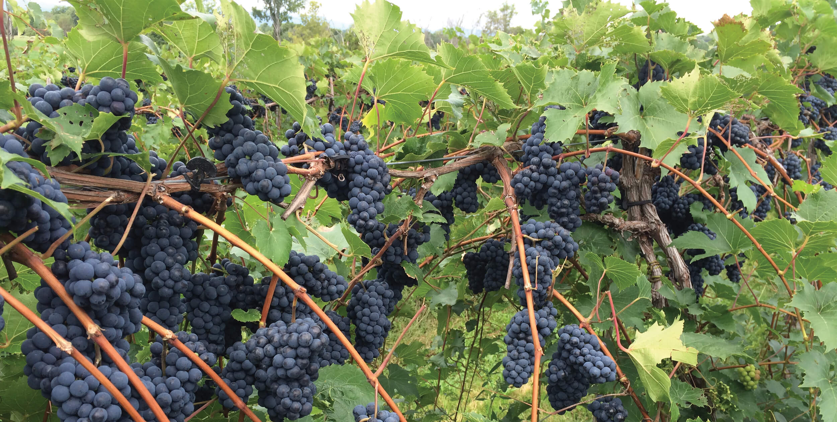

I am the vine; you are the branches. - John 15:5

Prelude Michelle Wilkinson

Welcome Pastor Lee

Call to Worship Rev. Melvin Woodworth
One: Come to the household of love, for God is love.
All: As we abide in love, we abide in God.
One: Come to the vineyard of grace, for God is gracious.
All: As we abide in the vine, we bear love's fruit.
One: Come to the table of plenty, for the Risen One invites us.
All: As we abide in God, God abides in us.
- key words and imagery from 1 John 4, John 15

Song Lord, Be Glorified # 2150 Vocals with Abbie Grimstad

Unison Prayer
Self-giving God,
Here we are to worship and to wonder, to sing and to surrender, to pour out and to be filled. Thank you for the Way you’ve given. Help us to trust, follow, and fully live. In the name of Jesus, Lord of the Dance, we pray. Amen.

Song of illumination Teach Us To Dance
(Worship Design Studio, G. Kendrick, S. Thompson, G. Shpherd, arr: C. Bell)
Modified from singular me to plural us.

Teach us to dance to the beat of your heart.
Teach us to move in the power of your Spirit.
Teach us to live in the light of your presence!
Teach us to dance to the beat of your heart.

Scripture John 15:1-8 Michele Feikema

Message Connecting for Life

Breakout Room Discussion Questions
1. 1. What helps you to abide in (remain in) God/Love? What hinders?
2. Tell a story about running out of gas literally or spiritually.
As you reflect on that experience, where do you see God in it?
3. When/where/with whom have you known God-like love?

Consecration of Our Communion Elements

Communion Song from Marcia McFee's Worship Design Studio:

When you meet, take this bread which is my life
Broken now, for a hungry world.
Gather near, take this cup which is my blood (love)
Poured out now, for a thirsty world.

Receiving the bread and drink
The body of Christ, given for you.
The blood (Love/Anima) of Christ, poured out for you.

Prayers of the People
Breath, silence, and words…..concluding with the Lord's Prayer # 895

Offering with selection by Michelle Wilkinson
Financial offerings can be mailed to SUMC c/o Carol Lawrence, PO Box 458, Snoqualmie, WA 98065. Or use PayPal on the give page of our website, www.snoqualmieumc.org. Thank you!

Community Announcements & Invitations see below

Closing Song Seek My Way, by Harley Brumbaugh

Benediction

Thank you for being here today.

Snoqualmie United Methodist
Box 458 Snoqualmie, WA 98065
www.snoqualmieumc.org 425-888-1697

What are we doing here?
We are becoming the voice, hands and heart of Christ, fostering discipleship that transforms the world! * We are practicing radical hospitality, passionate worship, intentional faith development, risk-taking mission & service, and extravagant generosity. * Together in Christ we are caring for our congregation, welcoming the stranger, and empowered for our callings in community.

- - - - - Community Announcements & Invitations - - - - -

* Finance Team Update: As of end-of-April revenue is exceeding expenses! However, our budget for the year is estimating a shortfall of $3, 500. Thanks so much for your faithful generosity - at all levels - through these challenging months. We look forward to reconnecting in person and purpose, making a difference in our neighborhoods and world.

* Next Sunday is Mothers' Day: Send a digital photo and/or a few words that represent your mom if you like. Send by Friday 4 pm to Pastor Lee (text 425-444-5556, or email pastorlee@snoqualmieumc.org).

* Thanks to Toddie Downs and all who are contributing to the upcoming Circuit Rider Newsletter. Watch your inbox for May/June edition soon.

* Kid’s Story Time with Wendy, Anna, Andrew, and room for more friends on Sundays 7 pm. Bring up to three jokes (the innocent kind), and connect on Zoom: https://greaternw.zoom.us/j/94179861022 .

* Congregational Conversation moved to May 16 shortly after worship, 11:45 am - 12:15 pm. (Originally planned for May 2. The delay allows us to know more about re-opening prospects, and to prepare an upcoming Reconciling Ministries survey - topics that are likely to come up.) What's on your mind relating to congregational life and neighborhood ministries? What ideas, questions, suggestions are stirring? We try to schedule "congregational conversations" after worship every couple of months in hopes of enhancing communications and fostering creativity all around. No pre-set agenda.

* Virtual Coffee Breaks continue Fridays (tomorrow) at 10 am. Join Tom Boord and friends for a time of socializing and casual conversation. Gather on zoom through https://greaternw.zoom.us/j/99811626121. If dialing in by phone, call 253-215-8782 and offer meeting ID number 99811626121 when asked.
* Weekly Learning Circle, Tuesdays 6:30 - 8 pm - Now reading How the Bible Actually Works: In Which I Explain How an Ancient, Ambiguous, and Diverse Book Leads Us to Wisdom Rather Than Answers - and Why That's Great News by Peter Enns. Ed Morrison is facilitating. Chapters 1 through 3 this week. Books are available through your favorite bookseller, or arrange a copy through Pastor Lee (425-444-5556). Newcomers always welcome. Enter the zoom gathering through https://greaternw.zoom.us/j/99508693698 or call 1 253-215-8782 and offer meeting ID number 99508693698 when asked.

* Will Downs, Charles Grant Finney, Rachel Holloway, and Aaron Willson are on the verge of high school graduation! We will celebrate them June 27 in worship, and watch for additional ways to support them in this milestone. If you or a family member are graduating from high school, college, or other significant program this spring - please let us know! We'd like to include you too. (Contact Pastor Lee at 425-444-5556, pastorlee@snoqualmieumc.org.)

* Work Party Saturday May 15 at 10:30 am. Join our Trustees for a morning of chores around the church building. Pizza & salad lunch at noon.

- - - - - - - - - - - - - - - - - - - - - - - - - - - - - - - -

